ER DIAGRAM

NAME: VISMITAA S

REGISTER NUMBER:2648552

Business Case: INTERNSHIP TRACKING SYSTEM

1. Introduction
The Internship Tracking System is designed to manage and track student’s internships, evaluations, mentors and companies

2. Objective
The objective of this business is to stores information about students, companies offering internships, mentors who guide students, internship details, and evaluation records. The system helps educational institutions track student internships, monitor progress, and maintain evaluation records efficiently.

3. System Requirements
1. User & Identity Management
Student Management
- The system must track student profiles with a unique identifier (Student_id).
- Each student profile must record their Student_name, Email_id, Phone_number, and the current academic Year.
- A student must be permanently associated with an academic Department.

Mentor Management
- The system must maintain records of assigned mentors, uniquely identified by a Mentor_id.
- Mentor profiles must store their Mentor_name, Phone_number, Email, and professional Designation.
- Supervision Tracking: The system must support a Monitors relationship where a Mentor oversees and tracks the progress of a Student.
2. Internship & Company Management
Company Profiles
- The system must catalog participating organizations using a unique Company_id.
- For each organization, the database must capture the Company_name, physical Location, an Industry_id , and a primary Contact_email.
Internship Positions
- The system must manage specific internship listings, uniquely identified by an Internship_id.
- Each internship position must log its Internship_title, Start_date, and End_date.
- A Company hosts or Offers one or more Internship positions.
3. Engagement & Evaluation Workflows
Internship Undertakings
- The system must track when a Student officially Undertakes an Internship.
- This core engagement must maintain a dynamic, real-time Internship_status attribute to see if the internship is completed or pending.
- An active internship must be overseen by a supervisor, represented by the Guides relationship linking a Mentor to the Internship.
Performance Evaluation
- The system must generate formal Evaluation records for tracking academic and practical performance.
- Each evaluation must maintain clear relational links back to the specific Student_id and Internship_id being reviewed.
- The evaluation record must securely log structural attributes including Evaluation_marks, overall Score, a derived letter Grade, and qualitative supervisor Remarks.
- The system must explicitly track that an Evaluation is something a student Receives and an internship placement Has to ensure full accountability between all parties.

4. Database Design Highlights
Relationship & Cardinality Mapping
- A Mentor Monitors a Student.
Cardinality: One-to-Many because a single Mentor can monitor and supervise many Students simultaneously. However, a student is assigned to exactly one specific mentor for their primary oversight.
- A Student Undertakes an Internship.
Cardinality: One-to-One because a single Student undergoes a single Internship
- A Mentor Guides that same Internship.
Cardinality: One-to-Many because a single Mentor guides more than one student for the Internship
- Internship Has Evaluation.
Cardinality: One-to-Many because a single Internship have two Internship status either Pending or Complete based on the status the number of evaluation goes on.
- Company Offers Internship
Cardinality: One-to-Many because One company can provide Internship to more than one student
- Student Recieves Evaluation
- Cardinality: One-to-Many because the Evaluation depends on the Internship status
5. Benefits
- Reduced redundancy
- Clean data normalization
- High monitoring
- Robustness performance

ER DIAGRAM

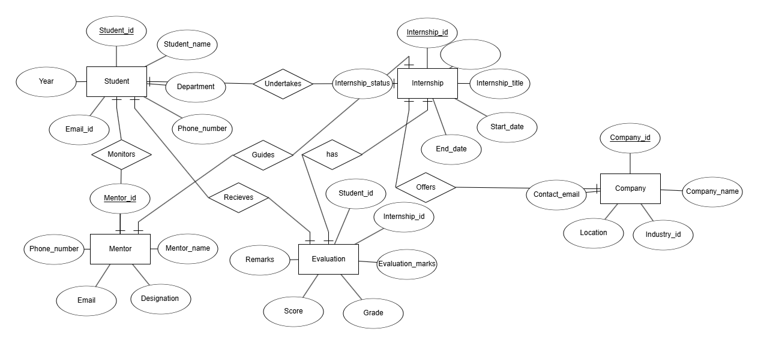
This ER diagram models a complete internship management process. Students undertake internships offered by companies, mentors monitor and guide them, and evaluations record their performance. The design consists of four strong entities (Student, Internship, Company, Mentor) and one associative entity (Evaluation) connected through binary relationships with mostly 1:M cardinalities, making it suitable for efficient internship tracking and performance assessment

